KENYA ASSEMBLIES OF GOD
KAMIRITHU CHRISTIAN CENTRE
P.O. BOX 660 LIMURU CELL: 0722 479244
E-mail kahorapeter@yahoo.co.uk

CHILD SPONSOR BIOGRAPHICAL FORM

ORPHANS AND VULNERABLE CHILDREN CARE AND SUPPORT PROGRAM

CATEGORY OF CHILD:PARTIAL ORPHAN.
FULL NAME: Paul Mutiso
AGE: 18Yrs
BIRTH DATE: 10th October 1995
CLASS: Form 4 secondary school.
VILLAGE: Salama SUB LOCATION: Kiima Kiu
LOCATION: Kiima Kiu COUNTY: Makueni
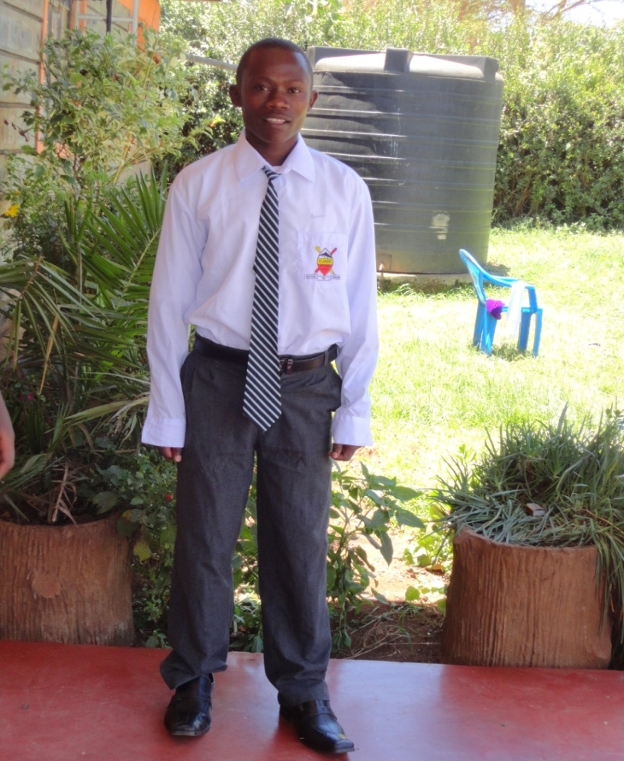

BEST SUBJECTS,MATHEMATICS.
AMBITION: To become a MILITARY
NUMBER OF SIMBLINGS: Two

CONDITION OF FAMILY/CHILD
Paul is the second born in the family. The poor father married at an old age. He had six children to take care of which was a toll order for the man. The mother went mad and ran away from home. He felt neglected and ran to the streets of Nairobi.

OTHER COMMENTS ABOUT THE CHILD
He has a great passion for education and if supported can achieve his vision of becoming a military soldier. He is also friendly and God fearing He also needs financial support to complete his studies
KENYA ASSEMBLIES OF GOD
KAMIRITHU CHRISTIAN CENTRE
P.O. BOX 660 LIMURU CELL: 0722 479244
E-mail kahorapeter@yahoo.co.uk

CHILD SPONSOR BIOGRAPHICAL FORM

ORPHANS AND VULNERABLE CHILDREN CARE AND SUPPORT PROGRAM

CATEGORY OF THE CHILD
FULL NAME: Shapashina Sipoi
AGE : 18Yrs
DATE OF BIRTH: 2nd January 1996
CLASS: Form THREE Secondary School
VILLAGE : Imbuko SUBLOCATION, Isinya LOCATION ,Kajiado county

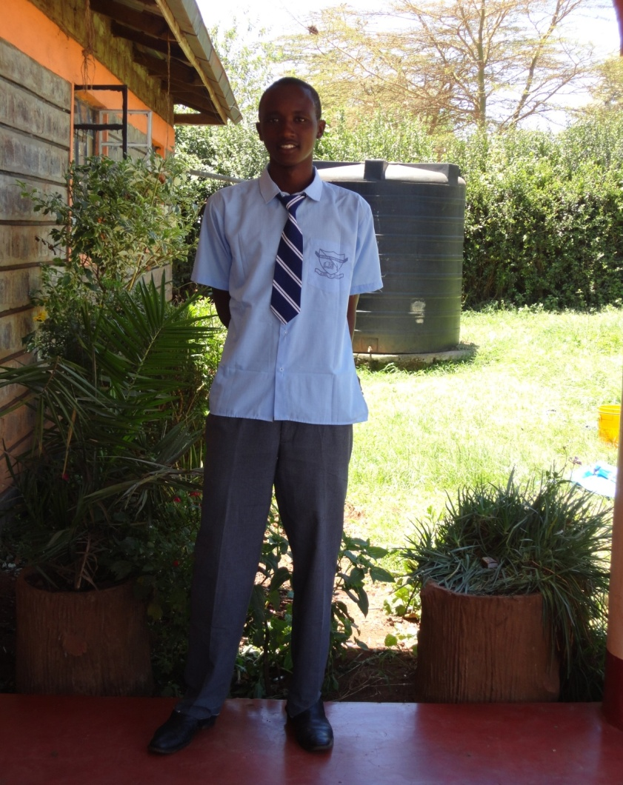

BEST SUBJECTS:ENGLISH
AMBITION:TO BECOME AN ARMY.
NUMBER OF SIMBLINGS: THREE,

CONDITION OF THE FAMILY/CHILD
Shapashina is an orphan. His mother passed away in the year 2005 due to HIV. She had earlier been married but divorced before she got the subject. His mother left behind 7 children who are currently living with relatives. The boy was under his maternal auntie who had four other children. Catering for all their needs was overwhelming, so he took to the street

OTHER COMMENT ABOUT THE CHILD
Shapashina is a bright boy whose dream goal is being an army. He loves education and really works hard. Besides that he is friendly but emotional. He needs a lot of support moral spiritual and even financially to boost his education.

KENYA ASSEMBLIES OF GOD
KAMIRITHU CHRISTIAN CENTRE
P.O. BOX 660 LIMURU CELL: 0722 479244
E-mail kahorapeter@yahoo.co.uk

CHILD SPONSOR BIOGRAPHICAL FORM
ORPHANS AND VULNERABLE CHILDREN CARE AND SUPPORT PROGRAM
CATEGORY OF THE CHILD
FULL NAME: John Nganga
AGE 18yrs
DATE OF BIRTH 20th January 1996
CLASS Form Three
VILLAGE: Baringo SUB-LOCATION, Mawingu LOCATION, Nakuru COUNTY
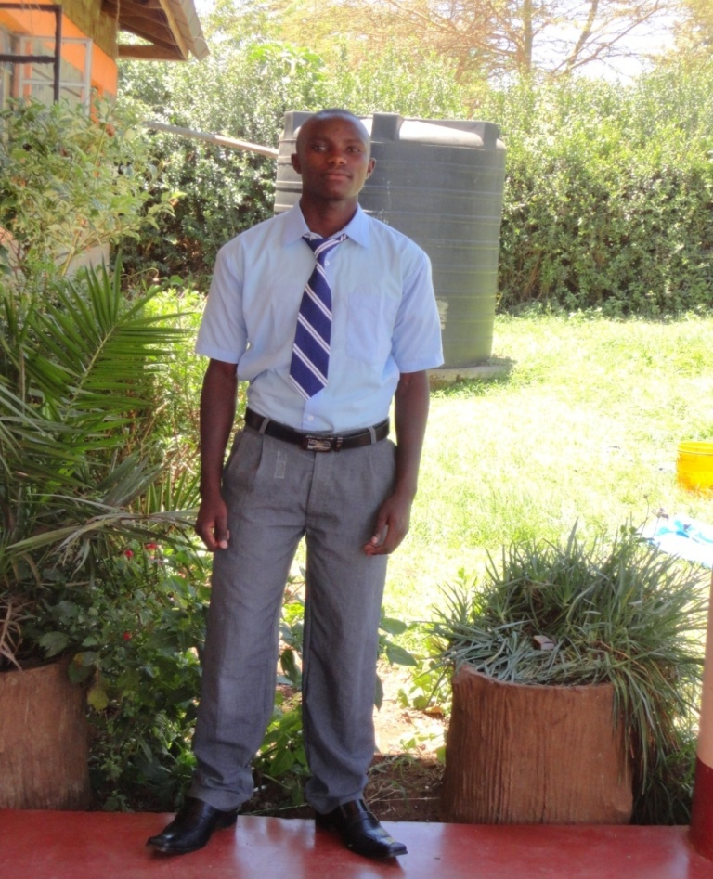

BEST SUBJECTS,SCIENCE SUBJETS
AMBITION, TO BECOME A DOCTOR
NUMBER OF SIMBLINGS.ONE

COMMENT ABOUT THE FAMILY/CHILD,
John is an orphan. His parents died living him and his sibling with his grandmother who was then 80 yrs old. He dropped school due to lack of food and went for job searching at the age of 10. He was rescued from child labor and joined Bethel Kids home.

OTHER COMMENT ABOUT THE CHILD
John is a humble well disciplined boy who loves God. He is obedient and responsible. He loves education. His dream lies in medical field. If supported he can perform well in high school and college.

KENYA ASSEMBLIES OF GOD
KAMIRITHU CHRISTIAN CENTRE
P.O. BOX 660 LIMURU CELL: 0722 479244
E-mail kahorapeter@yahoo.co.uk

CHILD SPONSOR BIOGRAPHICAL FORM
ORPHANS AND VULNERABLE CHILDREN CARE AND SUPPORT PROGRAM
CATEGORY OF THE CHILD
FULL NAME: TRACY WANJIKU,
AGE 17YRS
DATE OF BIRTH 4th MAY 1996,
CLASS FORM FOUR,
VILLAGE, MAGINA SUB-LOCATION; MAGINA; LOCATION KIMENDE, COUNTY KIAMBU.

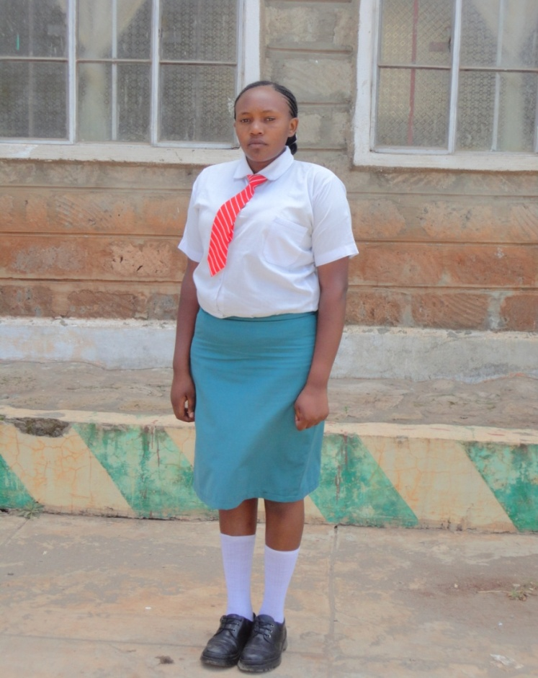

BEST SUBJECTS,ENGLISH .
AMBITION, TO BECOME AN ACCOUNTANT
NUMBER OF SIMBLINGS, THREE

COMMENT ABOUT THE FAMILY/CHILD
Tracy is an AIDS orphan. The late single mother had rented a room at Magina trading centre. The mother died living the girl and the brother under the hands of well – wishers, later running into the streets.

OTHER COMMENT ABOUT THE CHILD
She gets along with others with a bit of difficulties. This is due to her maturity tendencies. She is a bit disturbed emotionally but a good worship leader. Her dream goal is becoming an accountant of which she works hard to achieve.

KENYA ASSEMBLIES OF GOD
KAMIRITHU CHRISTIAN CENTRE
P.O. BOX 660 LIMURU CELL: 0722 479244
E-mail kahorapeter@yahoo.co.uk

CHILD SPONSOR BIOGRAPHICAL FORM
ORPHANS AND VULNERABLE CHILDREN CARE AND SUPPORT PROGRAM
CATEGORY OF THE CHILD
FULL NAME: IRENE CHEPKEMOI
AGE 16YRS DATE OF BIRTH 10th NOVEMBER1997
CLASS FORM THREE
VILLAGE: SUNSET SUB-LOCATION,BOMET ,KAJIADO COUNTY
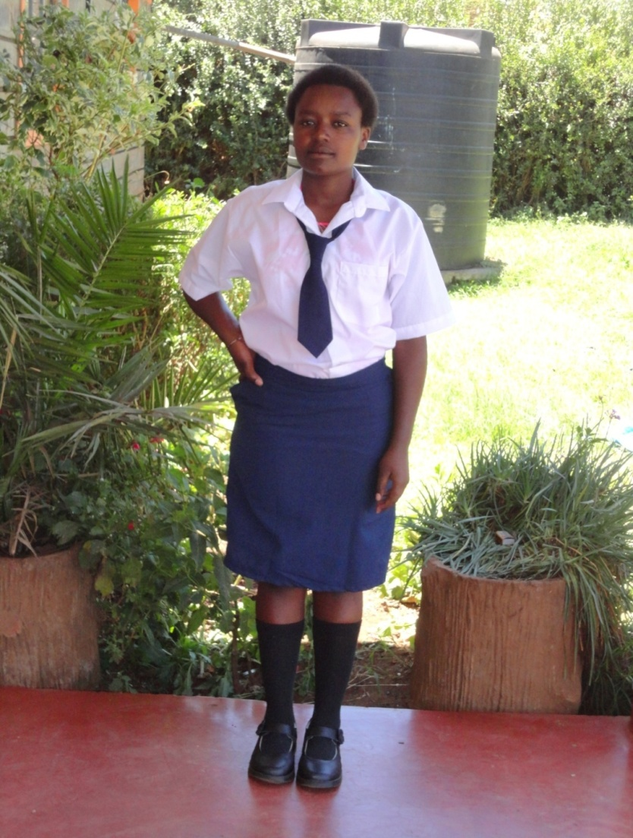

BEST SUBJECTS,ENGLISH.
AMBITION; TO BECOME AN ACCOUNTANT,
NUMBER OF SIMBLINGS, THREE,
COMMENT ABOUT THE FAMILY/CHILD
Irene was born of a single mother who died living her plus two other siblings to be fend for by a grandfather who is a widower and having other orphaned cousins to be fend for by the same grandfather, living her most of the times neglected.

MORE COMMENT ABOUT THE CHILD
Irene is a happy girl who is able to get along with others. She easily apologizes when she errs. She is stable emotionally but needs a lot of spiritual nurturing. She loves education and her dream goal is becoming an accountant. Requires financial support towards her education. She can make it in life.

KENYA ASSEMBLIES OF GOD
KAMIRITHU CHRISTIAN CENTRE
P.O. BOX 660 LIMURU CELL: 0722 479244
E-mail kahorapeter@yahoo.co.uk

CHILD SPONSOR BIOGRAPHICAL FORM

ORPHANS AND VULNERABLE CHILDREN CARE AND SUPPORT PROGRAM

CATEGORY OF CHILD
FULL NAME: SUSAN NJOKI ,
AGE 17 DATE OF BIRTH 11th AUGUST 1996,
CLASS FORM FOUR
VILLAGE: KWAHARAKA LOCATION, NYANDARUA COUNTY
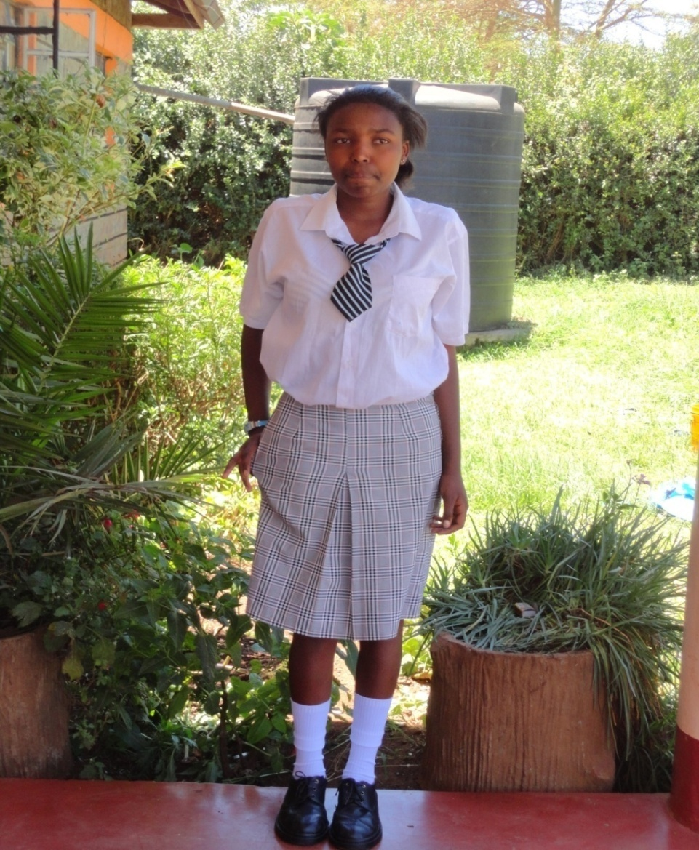
BEST SUBJECTS;SCIENCE SUBJECTS.
AMBITION: TO BECOME A MEDICAL DOCTOR
NUMBER OF SIMBLINGS: FOUR

COMMENT ABOUT THE FAMILY/THE CHILD
Susan is a total orphan .her father died in the year 2003 while the mother passed on in2005 due to AIDS. She and her siblings were left under the care of grandmother and aunt who could not afford to feed and educate her.

OTHER COMMENT ABOUT THE CHILD
She is a polite girl but a bit reserved. Always neat. She needs financial support to take her through secondary and college course.
KENYA ASSEMBLIES OF GOD
KAMIRITHU CHRISTIAN CENTRE
P.O. BOX 660 LIMURU CELL: 0722 479244
E-mail kahorapeter@yahoo.co.uk

CHILD SPONSOR BIOGRAPHICAL FORM
ORPHANS AND VULNERABLE CHILDREN CARE AND SUPPORT PROGRAM

CATEGORY OF THE CHILD,TOTAL ORPHAN
FULL NAME: DENNIS MAINA
AGE 17 YEARS DATE OF BIRTH. N/A
CLASS: FIRST YEAR IN POLYTECHNICH,
VILLAGE: KAYOLE, NAIROBI COUNTY
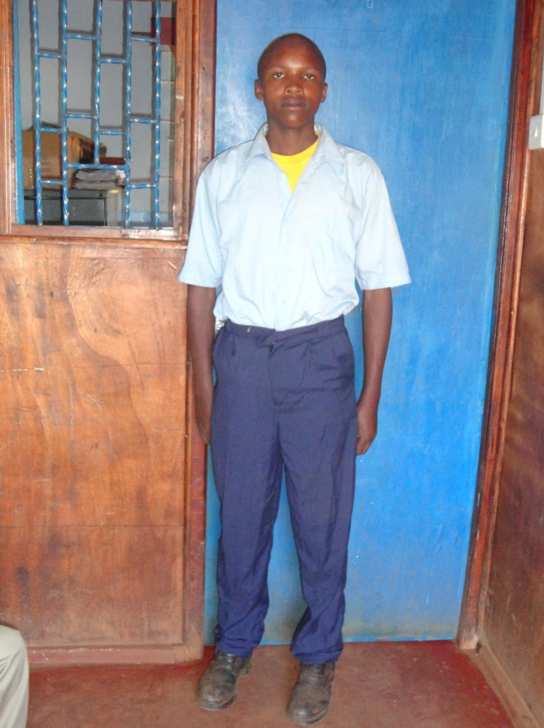
BEST SUBJECTS ART,CRAFT
AMBITION; TO BECOME A WELDER
NUMBER OF SIMBLINGS
COMMENT ABOUT THE FAMILY/ CHILD
The parents separated for unknown reasons. The mother was unable to fend for the boy and hence he ran to the streets of Nairobi. The mother who later died of AIDS.
OTHER COMMENT ABOUT THE CHILD
The boy has some violence tendencies making him unable to relate easily with other kids. He requires moral and spiritual nurturing. Dennis is gifted in craft work and can be successful in future if financially assisted to complete his course.

KENYA ASSEMBLIES OF GOD
KAMIRITHU CHRISTIAN CENTRE
P.O. BOX 660 LIMURU CELL: 0722 479244
E-mail kahorapeter@yahoo.co.uk

CHILD SPONSOR BIOGRAPHICAL FORM

ORPHANS AND VULNERABLE CHILDREN CARE AND SUPPORT PROGRAM
NAME OF A CHILD; ANTONNY NGANGA
CATEGORU OF A CHILD, TOTAL ORPHAN
AGE 18 YEARS
DATE OF BIRTH 12TH MAY1996
CLASS FIRST YEAR IN POLYTECHNIC
VILLAGE MATHARE: NAIROBI COUNTY
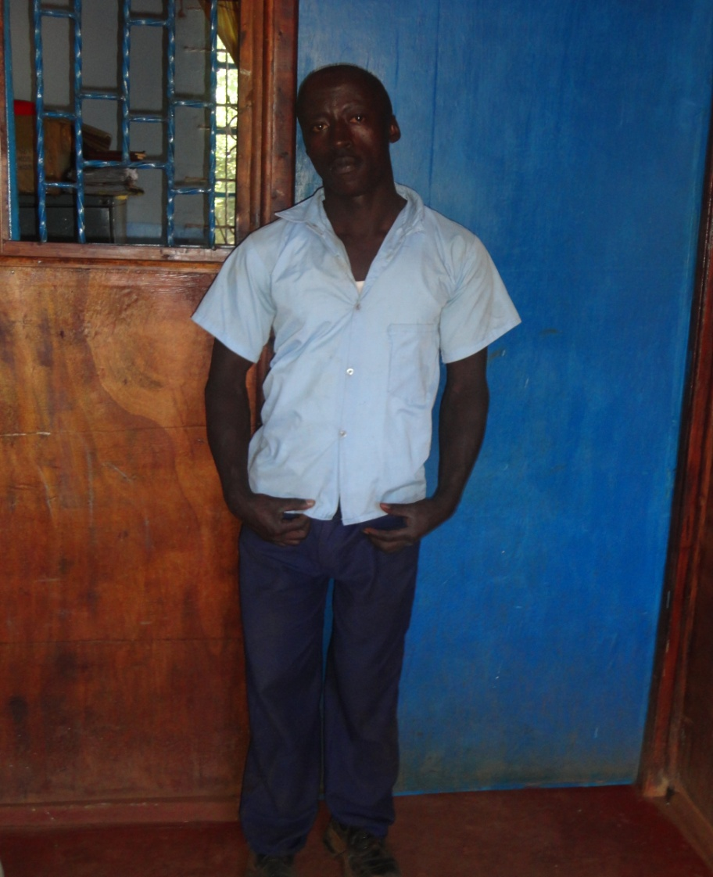

BEST SUBJECTS ART, CRAFT, MUSIC
AMBITION- TO BECOME WELDER
NUMBER OF SIMBLINGS,
COMMENT ABOUT THE FAMILY/CHILD…….
Anthony is a child of a drunkard and irresponsible mother. When he was a toddler he fell into the fire and had severe burns which did maim him. This is why the boy is not able to walk properly. The mother would not bother until his aged grandmother came to his aid. However she could not manage to bring him up together his sister who is also in Kenya Kids children’s home
MORE COMMENT ABOUT THE CHILD
He is playful and happy but sometimes can be violent. He has some internal unresolved issues. He needs social, moral and spiritual nurturing, However, he believes that disability is no inability and supported he can work great in future.

KENYA ASSEMBLIES OF GOD
KAMIRITHU CHRISTIAN CENTRE
P.O. BOX 660 LIMURU CELL: 0722 479244
E-mail kahorapeter@yahoo.co.uk

CHILD SPONSOR BIOGRAPHICAL FORM
ORPHANS AND VULNERABLE CHILDREN CARE AND SUPPORT PROGRAM
CATEGORY OF A CHILD,TOTAL ORPHAN
FULL NAME CHRISTINE WANJIRU;
AGE 16YEARS
DATE OF BIRTH 10th APRIL 1998
CLASS FORM TWO

VILLAGE,NDEIYA, COUNTY KIAMBU

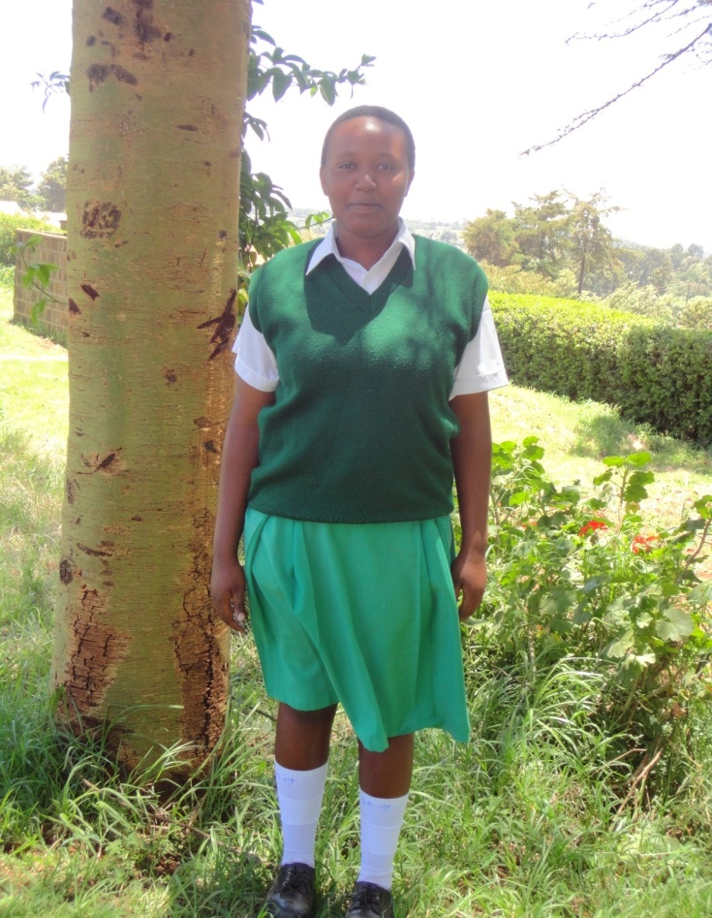

BEST SUBJECT; MATHEMATICS,
AMBITION, TO BECOME AN ACCOUNTANT;
NUMBER OF SIMBLINGS;
COMMENT ABOUT THE FAMILY,
The girl is an orphan. She was left under the care of her aunt who is vulnerable and has more children to look after.

OTHER COMMENT ABOUT THE CHILD
The girl is very hand working. She needs financial support to complete her education and achieve her accountant dream.

KENYA ASSEMBLIES OF GOD
KAMIRITHU CHRISTIAN CENTRE
P.O. BOX 660 LIMURU CELL: 0722 479244
E-mail kahorapeter@yahoo.co.uk
CHILD SPONSOR BIOGRAPHICAL FORM
ORPHANS AND VULNERABLE CHILDREN CARE AND SUPPORT PROGRAM

FULL NAME MARYANN NGENDO,
AGE 19 YRS DATE OF BIRTH 26th DECEMBER 1995
CLASS, FORM FOUR;SECONDARY SCHOOL.
CATEGORY OF A CHILD; TOTAL OPHARN
VILLAGE MLANGO KUBWA SUBLOCATION MLANGO KUBWA LOCATION MLANGO KUBWA COUNTY NAIROBI,

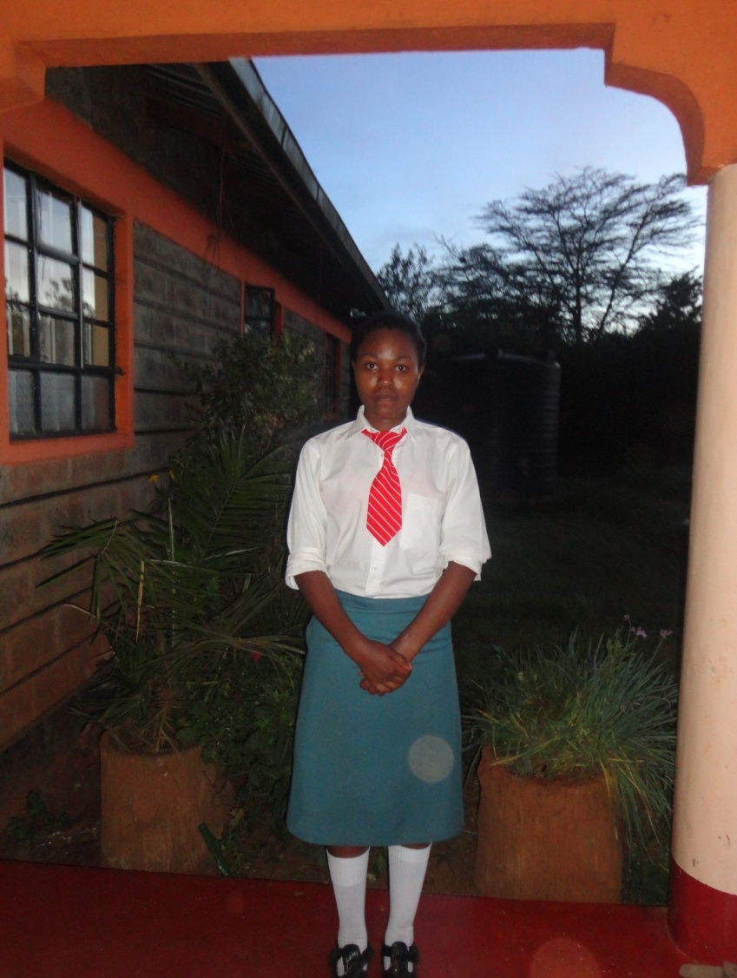
BEST SUBJECT; HISTORY, CHRISTIAN RELIGIOUS EDUCATION, ENGLISH
AMBITION;TO BECOME A LAWYER
NUMBER OF SIMBLINGS;THREE,

COMMENT ABOUT THE FAMILY /CHILD……
Mary is an orphaned child. The mother died of AIDS living her and her siblings with an aging poor grandmother in Mathare slums. The auntie who has her own children started taking care of her, since she could also not cater for all the needs of the girl, Mary ran to the streets of Nairobi.

OTHER COMMENT ABOUT THE CHILD
She gets along with others with a bit of difficulties. Though she has a very good heart she can a times be abusive. She is a bit disturbed and needs a lot of guidance on the area of boy-girl relationship.

KENYA ASSEMBLIES OF GOD
KAMIRITHU CHRISTIAN CENTRE
P.O. BOX 660 LIMURU CELL: 0722 479244
E-mail kahorapeter@yahoo.co.uk

CHILD SPONSOR BIOGRAPHICAL FORM
ORPHANS AND VULNERABLE CHILDREN CARE AND SUPPORT PROGRAM

CATEGORY OF THE CHILD
FULL NAME; PAUL NJAU,
CATEGORY OF THE CHILD, TOTAL OPHARN
AGE 18YRS DATE OF BIRTH; 2ND FEBRUARY 1996,
CLASS; FORM THREE;SECONDARY SCHOOL,
VILLAGE; NGENIA, KIAMBU COUNTY

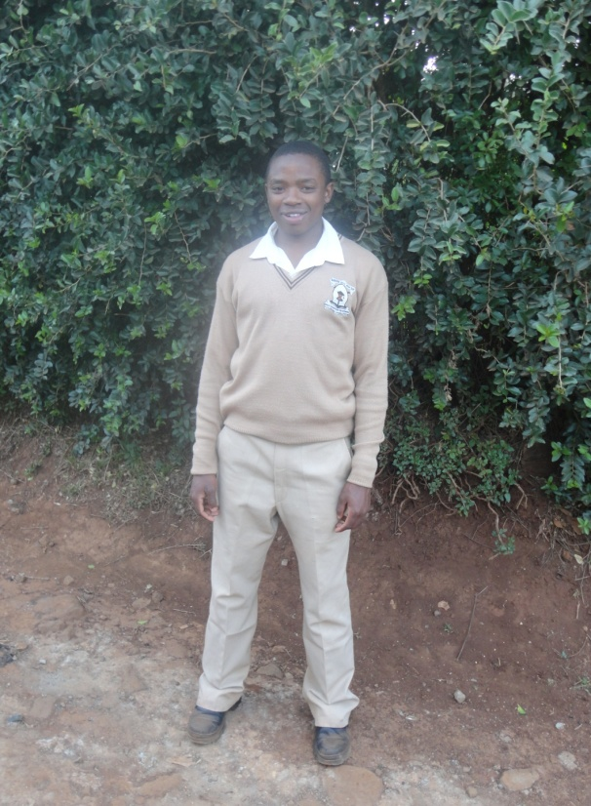
BEST SUBJECT; HISTORY, KISWAHILI, CHRISTIAN RELIGIUS EDUCATION,
AMBITION, TO BECOME A LAWYER.
NUMBER OF SIMBLINGS;THREE,

COMMENT ABOUT THE FAMILY/CHILD
The single mother died of AIDS living the boy plus his two siblings with his poor grandmother who had 12 children of her own. The grandfather has been bed ridden for a long time. The boy had to abandon the school and beg in the streets of Ruiru.

OTHER COMMENT ABOUT THE CHILD
Paul is friendly. He gets along easily with others though he can easily be hurt.
He loves education despite that he is an average student. Loves farming and animal husbandly. He fears God.

KENYA ASSEMBLIES OF GOD
KAMIRITHU CHRISTIAN CENTRE
P.O. BOX 660 LIMURU CELL: 0722 479244
E-mail kahorapeter@yahoo.co.uk

CHILD SPONSOR BIOGRAPHICAL FORM
ORPHANS AND VULNERABLE CHILDREN CARE AND SUPPORT PROGRAM

FULL NAME-DORCAS WAMBUI
CATEGORY OF THE CHILD’TOTAL ORPHAN.
AGE13YRS DATE OF BIRTH 10th APRIL 1998,
CLASS….7 IN PRIMARY SCHOOL
VILLAGE-ENGINEER, LOCATION-ENGINEER, COUNTY-NYANDARUA.

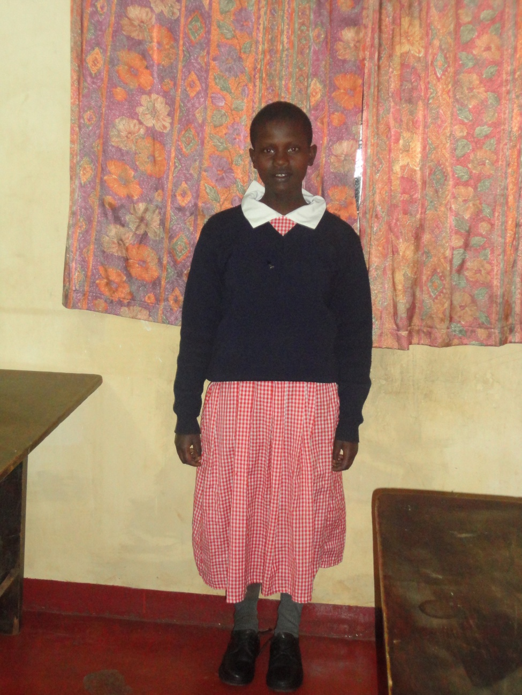
BEST SUBJECTS,SCIENCE,CHRISTIAN RELIGIOUS EDUCATION.
AMBITION,TO BECOME A SURGEON
NUMBER OF SIMBLINGS ;THREE.

COMMENT ABOUT THE FAMILY,
Dorcas single mother died of AIDS living her and her two siblings with ailing grandparents. She was in dire poverty and want necessitating her admission to Kenya Kids Centre.

OTHER COMMENT ABOUT THE CHILD,
Dorcas is a well behaved girl, humble and friendly. She is a good worship leader, loves education and is a good performer. She aspires to be a surgeon in future. The girl has some traits of withdrawal.

KENYA ASSEMBLIES OF GOD
KAMIRITHU CHRISTIAN CENTRE
P.O. BOX 660 LIMURU CELL: 0722 479244
E-mail kahorapeter@yahoo.co.uk

CHILD SPONSOR BIOGRAPHICAL FORM
ORPHANS AND VULNERABLE CHILDREN CARE AND SUPPORT PROGRAMME
CATEGORY OF THE CHILD,PARTIAL ORPHAN.
FULL NAME,TABITHA NJERI.
AGE 19YRS DATE OF BIRTH 8th JULY 1995,
CLASS ;LAST YEAR IN POLYTECHNICH,
VILLAGE-BANANALOCATION-BANANA,COUNTY-KIAMBU.
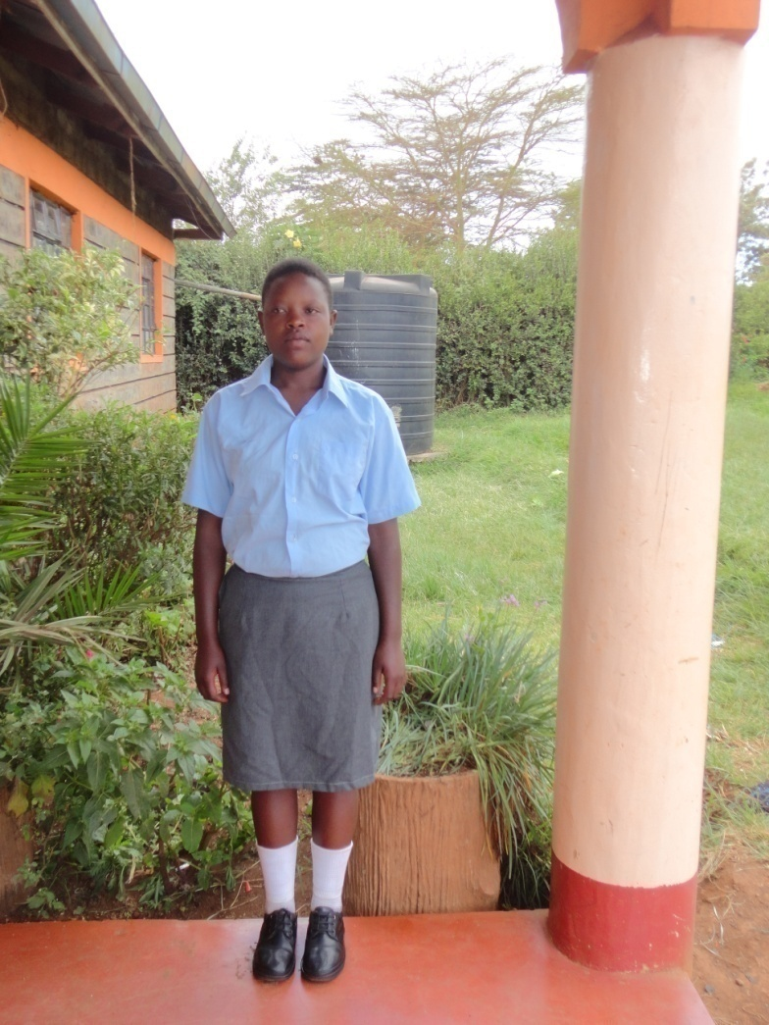
BEST SUBJETS,MUSIC,ART AMBITION, BEAUTY THERAPIST,
NUMBER OF SIMBLINGS –FIVE
COMMENT ABOUT THE FAMILY/CHILD
She is a partial orphan. Her mother is HIV infected and she has no stable means of support, forcing Tabitha to suffer in growing up.

OTHER COMMENT ABOUT TABITHA
She is good, polite and hardworking. Her performance in school is below average but gifted in art and craft work. Assisted she can complete her course and support herself in future.
KENYA ASSEMBLIES OF GOD
KAMIRITHU CHRISTIAN CENTRE
P.O. BOX 660 LIMURU CELL: 0722 479244
E-mail kahorapeter@yahoo.co.uk

CHILD SPONSOR BIOGRAPHICAL FORM
ORPHANS AND VULNERABLE CHILDREN CARE AND SUPPORT PROGRAM
FULL NAME MARGRET NJAMBI
CATEGORY OF THE CHILD,TOTAL ORPHAN.
AGE 16 YEARS,
DATE OF BIRTH,1998
CLASS FORM TWO,
VILLAGE –KAMIRITHU ,KIAMBU, COUNTY
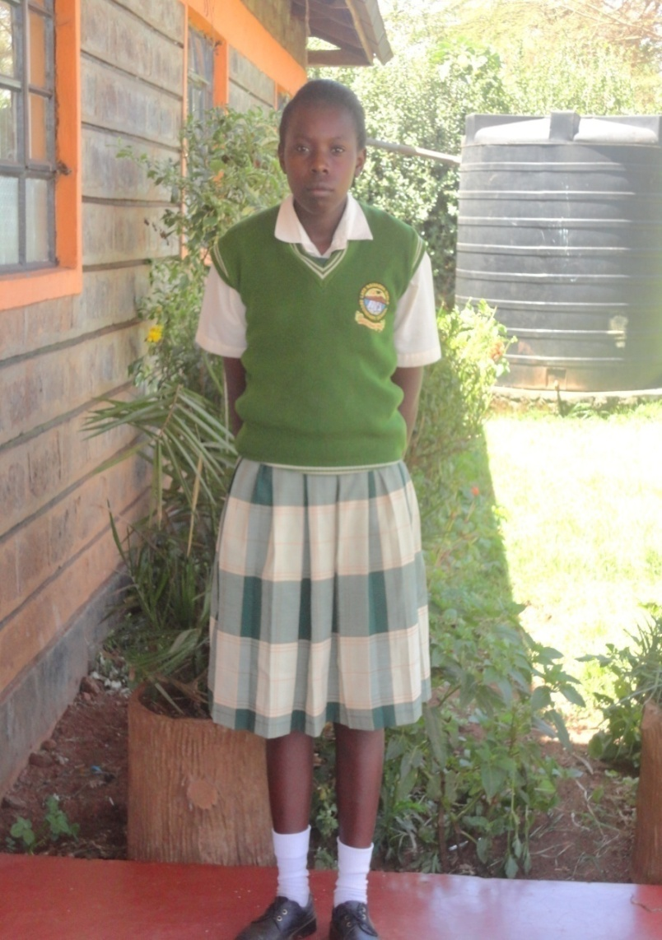
BEST SUBJECTS, CHEMISTRY AND MATHEMATICS,
AMBITION, TO BECOME A SURGEON
NUMBER OF SIMBLINGS TWO,COMMENT ABOUT THE FAMILY /CHILD. Her single mother died of AIDS living her and her brother under the care of the aged grandparents, who are unable to provide for her education.
MORE COMMENT ABOUT THE CHILD
She is a bright girl who has a dream of being a surgeon in future. She is humble, polite and disciplined girl. She is easily hurt and needs a lot of counseling. Margaret needs financial support to achieve her dream.
KENYA ASSEMBLIES OF GOD
KAMIRITHU CHRISTIAN CENTRE
P.O. BOX 660 LIMURU CELL: 0722 479244
E-mail kahorapeter@yahoo.co.uk
CHILD SPONSOR BIOGRAPHICAL FORM
ORPHANS AND VULNERABLE CHILDREN CARE AND SUPPORT PROGRAM

FULL NAME; JOSEPH WAMBUA;
CATEGORY OF THE CHILD,PARTIAL ORPHAN
AGE-18YRS DATE OF BIRTH; 8TH APRIL 1996.
CLASS, FORM TWO-SECONDARY SCHOOL.
VILLAGE.KAYOLE, SUB-LOCATION –MATOPENI ,LOCATION-KAYOLE COUNTY-NAIROBI.

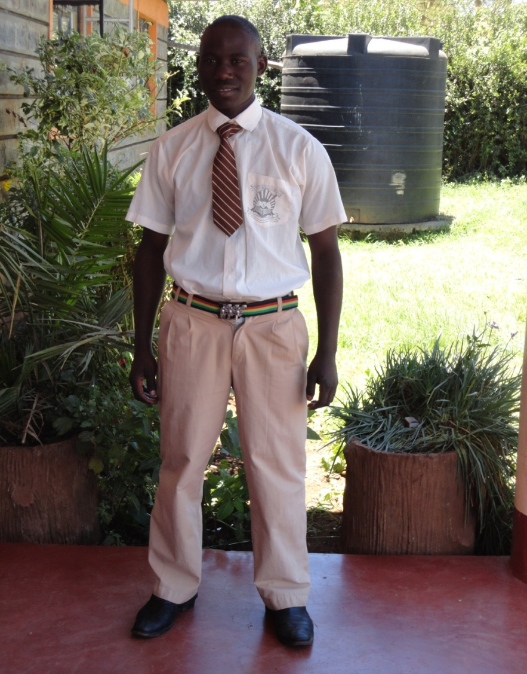
BEST SUBJECTS,HISTORY,ENGLISH AND BIOLOGY.
AMBITION,TO BECOME A MILITARY .
NUMBER OF SIMBLING;THREE.

COMMENT ABOUT THE FAMILY/JOSEPH
The parents are separated. The father is at Kakamega while the mother lives in Nairobi. The mother has been unable to take care of the children hence the boy ran to the streets. The mother washes other people’s clothes so as to sustain the family.

OTHER COMMENT ABOUT JOSEPH
He is emotionally stable. He is a bit slow and needs supervision in his working style. He sometimes can be violent. He aspires to be a military soldier and working on that.

KENYA ASSEMBLIES OF GOD
KAMIRITHU CHRISTIAN CENTRE
P.O. BOX 660 LIMURU CELL: 0722 479244
E-mail kahorapeter@yahoo.co.uk

CHILD SPONSOR BIOGRAPHICAL FORM
ORPHANS AND VULNERABLE CHILDREN CARE AND SUPPORT PROGRAM

FULL NAME ;MICHAEL KARANJA.
CATEGORY OF THE CHILD, VULNERABLE
AGE19YEARS DATE OF BIRTH APRIL 1994.
CLASS FORM THREE
VILLAGE-KAMIRITHU,COUNTY-KIAMBU

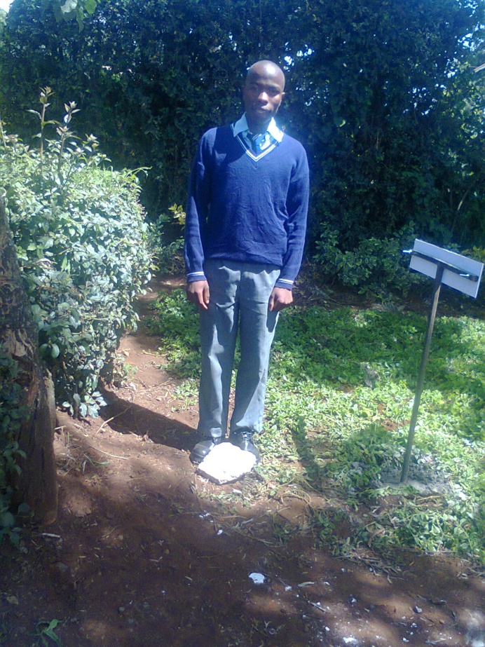

BEST SUBJECTS, MATHEMATICS, ENGLISH.
AMBITION; TO BECOME A LAWYER
NUMBER OF SIMBLINGS ,
COMMENT ABOUT THE FAMILY/MICHAEL
Michael is from a poor background . His father deserted the family living them at a very vulnerable
Condition. He was always sent home for school fees which made learning difficult for him.

OTHER COMMENT ABOUT MICHAEL…….

Michael is a polite and humble boy. He is hard working and responsible. He needs support to complete his studies and achieve his dream of becoming a lawyer and support his family.

